**Simple Registeration Page :**

**Steps :**

1)Create an Eclipse Dynamic Web Project

2)Add Dependencies :

* JSTL - 1.2.1
* Servlet API - 2.5
* MySQL - mysql-connector-java-8.0.13.jar

3)Used:

* IDE - Eclipse Neon.3
* JDK - 1.8 or later
* Apache Tomcat - 8.5

3)Project Structure:

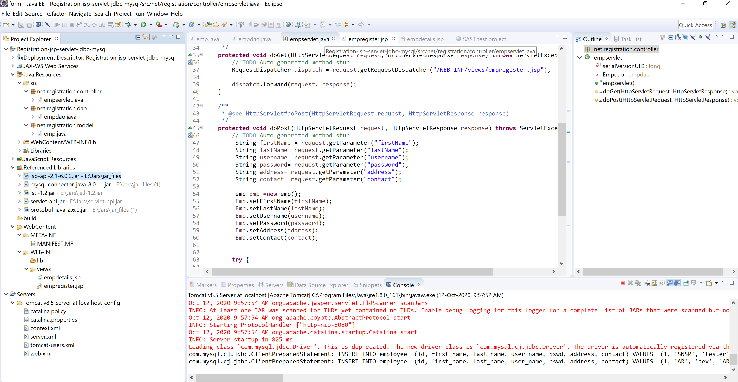

**Demo : Register page**

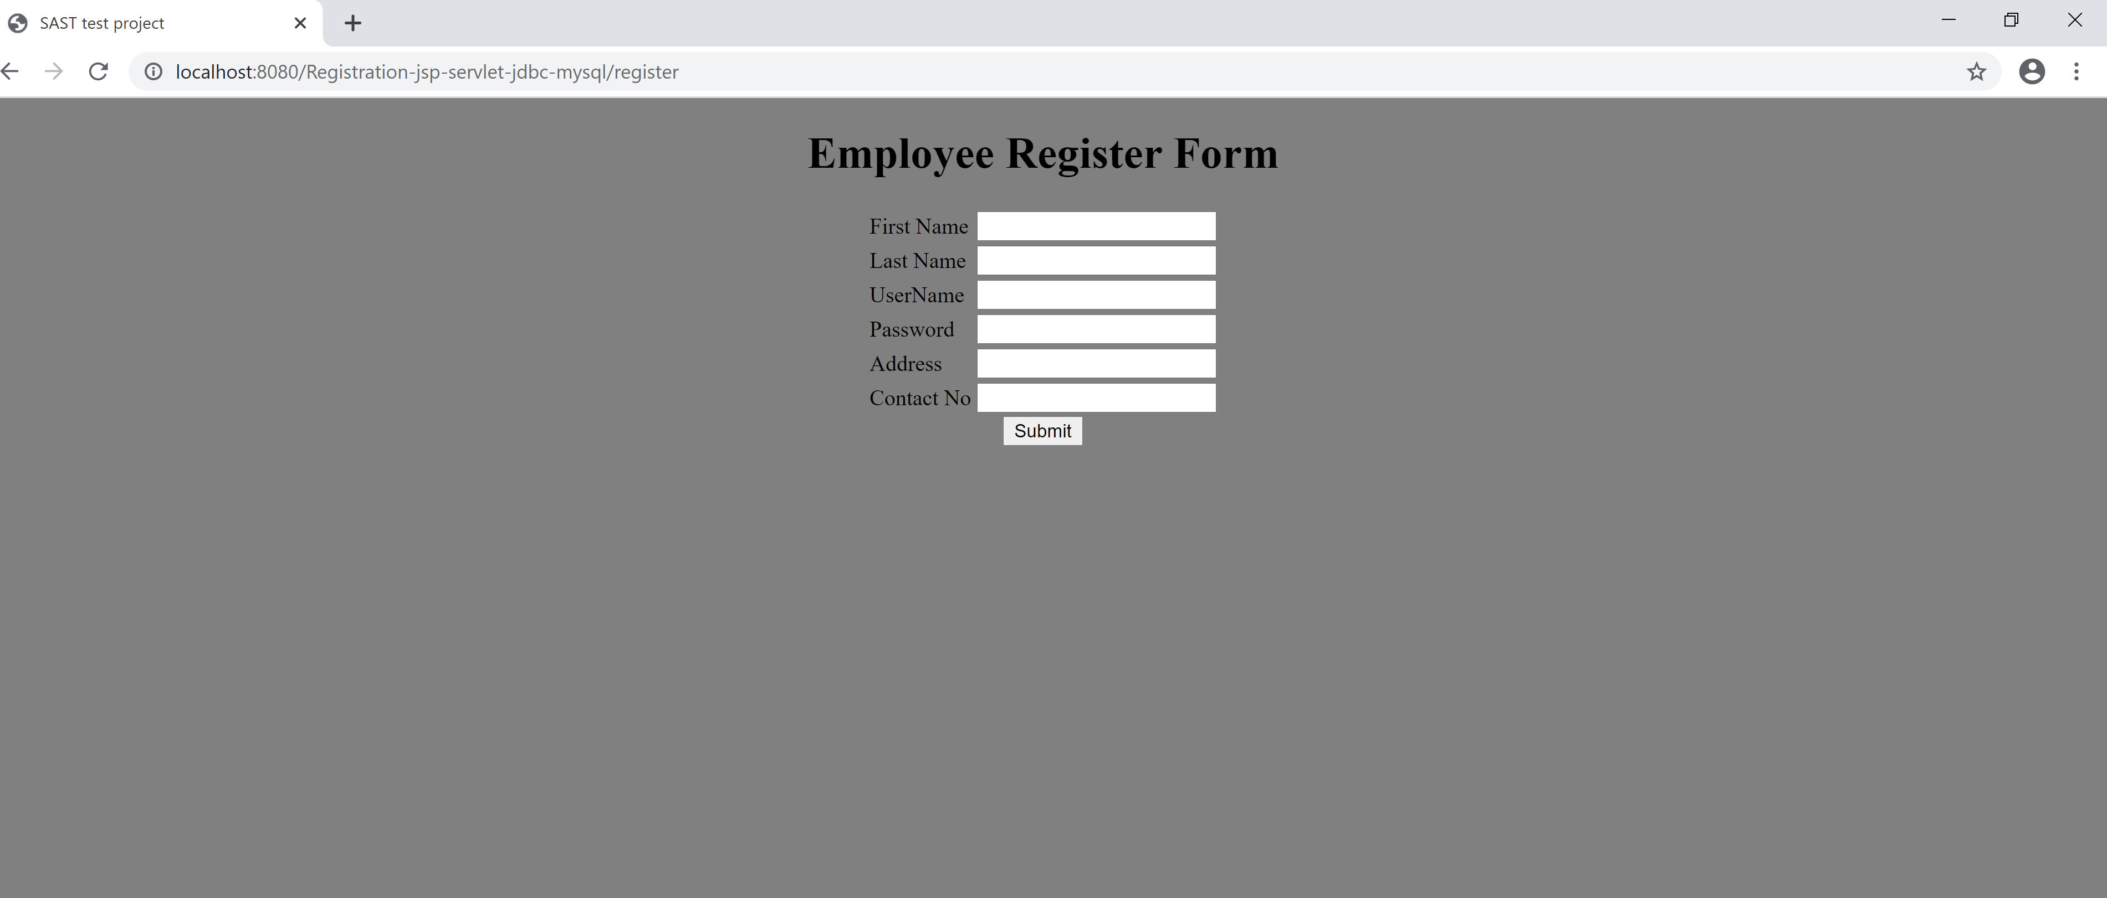

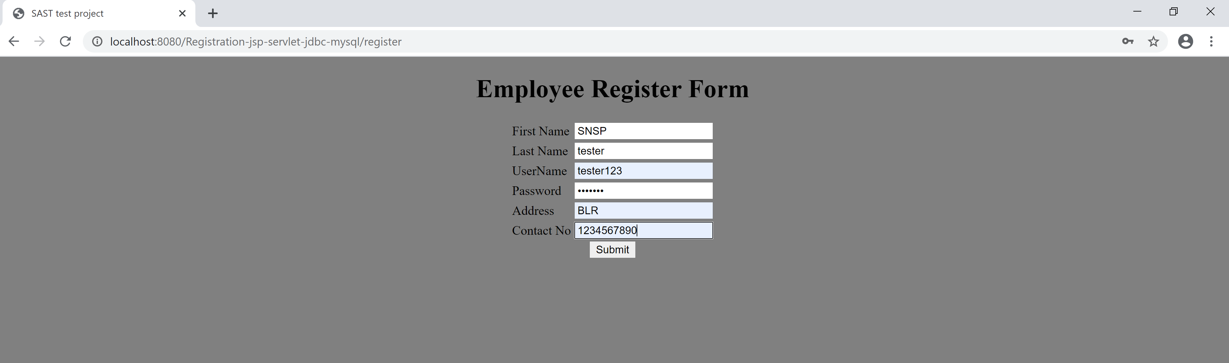

**Success Page**

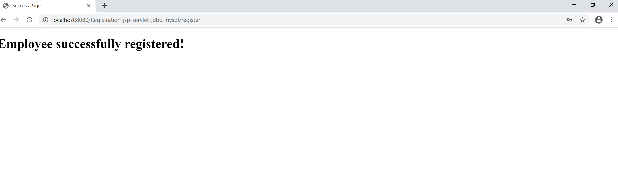

**Data inserted into DB:**

